Game Design Document: Rhythm Ride
Created By: Cole Shuler

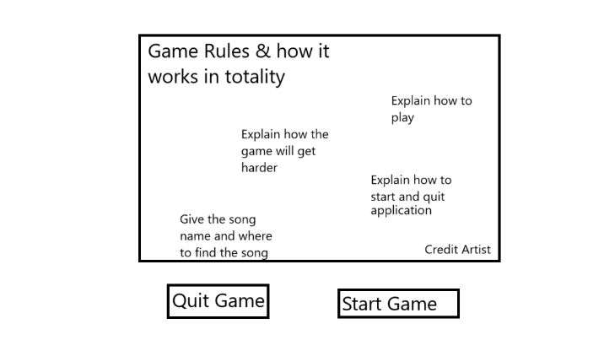

Main Title
This is the main title screen of the game, and it’s a simpler one for the simplicity of the game. This game is going to be a rhythm game for a song that my brother made (kite with no wind). The main title screen will have the game explanation as well as how to play, how to win, as long as credit to the song artist.

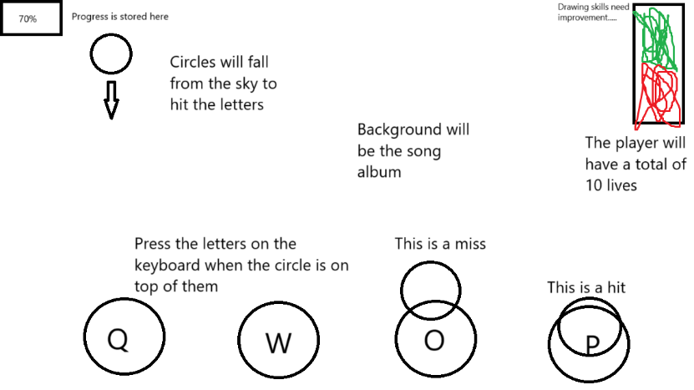
Main Game Screen
This is the main game screen. The game will have 4 keys you need to press (Q, W, O, and P) Pressing these keys will make them light up a different color. There will be circles that also fall from the top of the screen in specific spots. Hitting the key correlated to where the circle spawns in will keep you alive. If you miss a circle, you will take 1 point of damage. If you take 10 hits, you will have to restart. You will be able to track your progress with the progress bar in the top left, as well as your health in the top right. If you make it to the end of the song, you will have beat the game and will be sent back to the home screen to try again if you feel the urge to do so.

Sprites
The sprites that will be needed for the game will be 4 different colored buttons for the keys you need to press, as well as 3 different circles to represent their state (Falling, Hit, and Missed) These 3 states will help keep the player in check with how well they are doing. There will also need to be the album cover for the background. This will be used to help create the atmosphere of the game. The game will also use elements built into pygame, such as the standard blocks and text to create the home screen and UI elements.

Sprite List
The sprite list for the game will all be listed below. The sprites will all be found free of use besides the background which will be the cover art image for the song. The keys I found for the game are these…
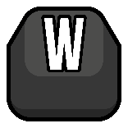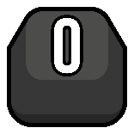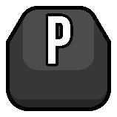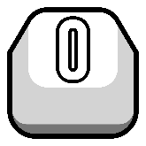
These keys will be white when not pressed and when pressed will turn into the darker counterpart. This will help the player determine if the key has been pressed or hasn’t been pressed. The Background will be the image listed below.

Game Redesign
After looking through everything I started with, I had to take a few steps back and think a little simpler to get the game going. The first thing I did was think about was how many keys I wanted this game to utilize and just how long I wanted the game to go on for. I also wanted a more unique way of starting the game, as I thought it would be cooler if the game just threw you in but also taught you how to play as well. Granted the game is not super complicated, I just wanted to make my game more unique to stand out from the rest.

Controls
To teach the player how to play, the first hit in the game will tell the player how to play; that way it keeps the player in the game and focuses on the goal. After all of the instructions the game will speed up so the player can be given a challenge, so the game isn’t super simple.

Song
Considering the song, I picked might be a little repetitive and too long, I decided to go with a song by the artist Potsu called Runaway. This song is a lot shorter to compensate for the lack of a health system. This will help make the game more playable and help the player by keeping them more interested in the game, as a 6-minute song can drag the experience.

Game Sprites
To compensate for a simpler game, the game will have a blank key at the bottom of the screen to represent the space bar. This key will change color depending on if it was clicked or not. The main objects falling from the sky will be a similar silhouette to the key on screen to help the player with figuring out the spacing and timing. The background will be a picture of the artist’s main character he uses to promote the song writer.

Old flaws
When going though when creating the 4-button system, the game started to slow down, and the rhythm part of the game became hard to create. Using only 1 button and creating a simpler system helps with slowdown and lag when the game is being played. The code was also causing issues with the title screen as well as the win and lose screen.

Pseudo Code
For the code I would like to make it as simple as possible for others to try and understand exactly how the game works and how the game is made. My Pseudo Code will be listed bellow to keep things consistent

Import pygame and simpleGE
Set the display to 640, 480 and rename the game to Rhythm Ride

Set up the music by importing pygames mixer
Load the song (Song.mp3)
Play the song on boot

Create a class named “Space” with the parameters being (simpleGE and Sprite)
Define and Initialize the self and scene
Set the current image to “Light_Space.png”
Set the size and position
Make the key active until 0
Make key pressed and music stopped false
Define the process
Create a way to determine the music being stopped to stop space’s actions
Create a system to swap the images between Dark_Space and Light_Space
Setup a timer to stop players from holding down the space key
Set the position and size

Create a class named “Title” with the parameters being (simpleGE and Sprite)
Define and Initialize the self and scene
Set the current image to “Title_Screen.jpg”
Set the size and position
Set the dy to move from the top of the screen down
Define the boundaries
Make it so the title screen disappears at the bottom of the screen

Create a class named “PH” with the parameters being (simpleGE and Sprite)
Define and Initialize the self and scene
Set the image to “PlaceHolder.jpg”
Set the size and position
Set up so self win to be false

Define the process for winning and losing
If the music has ended
Set up all the beats dy to 0
Set up all the beats to “Hit.png”
Set the image to “win.jpg
Set the size and position
If self win is not true, beat #1’s position is below the space, and is “beat.png”
Set the image to “lose.png”
Set the size and position

Set up 5 different beat classes with the parameters being (simpleGE and Sprite)
Define and Initialize the self and scene
Set the current image to “Beat.png”
Set the size and position (Different for all 5)
Set the dy to 0
Define the process for self
Set up the title screen startup
Set up the collision
Set up the different image system
Set up the lose system (For each individual beat)

Create a class named “Game” with the parameters being (simpleGE and Sprite)
Define and Initialize the self
Set up the Background with “BG.jpg”
Set up everything (Title, Space_Key, all 5 Beats, and PH)
Define main
Start up the game in “main”
Some things I would like to fix in the future
I think it would be amazing to try and fix the structure of the code to fix the buttons and beats so 4 buttons can be used. I would also like to implement a reset system to make the game more replay able. I would also like to redesign the way the beats fall. The way the beats fall is predictable and easy to determine. If I could make a system that would be easier to set up and possibly even easier to customize, I think it would have helped with designing the beat system in the game.

Wrap up thoughts
I think the overall game has a ton of potential for the future and can create an amazing backbone to an even bigger project. I think that there is a ton of different routes this could take, and I’m glad I was able to start the creation of the game.

